**NAAN MUDHALVAN**

SALESFORCE PROJECT REPORT

COLLEGE : **PONJESLY COLLEGE OF ENGINEERING**

BATCH-18

|  |  |  |
| --- | --- | --- |
| **NAME** | **NM ID** | **REG NO** |
| ARUNNKUMAR.M | 75770EC56312504A8CA40191A231E70A | 961820114307 |
| CHITHAMBARAM.KR | B7FDCDCA58780B59AAF4183FA8BAD2E6 | 961820114309 |
| SRI SANKAR.V.K | F9F116132DD08AB89AA4E83AEFAB0507 | 961820114326 |
| VISHWA.T | F442079B55BCBF98CD147057A6D82FC0 | 961820114329 |

**Step 1: Create a Salesforce Account**

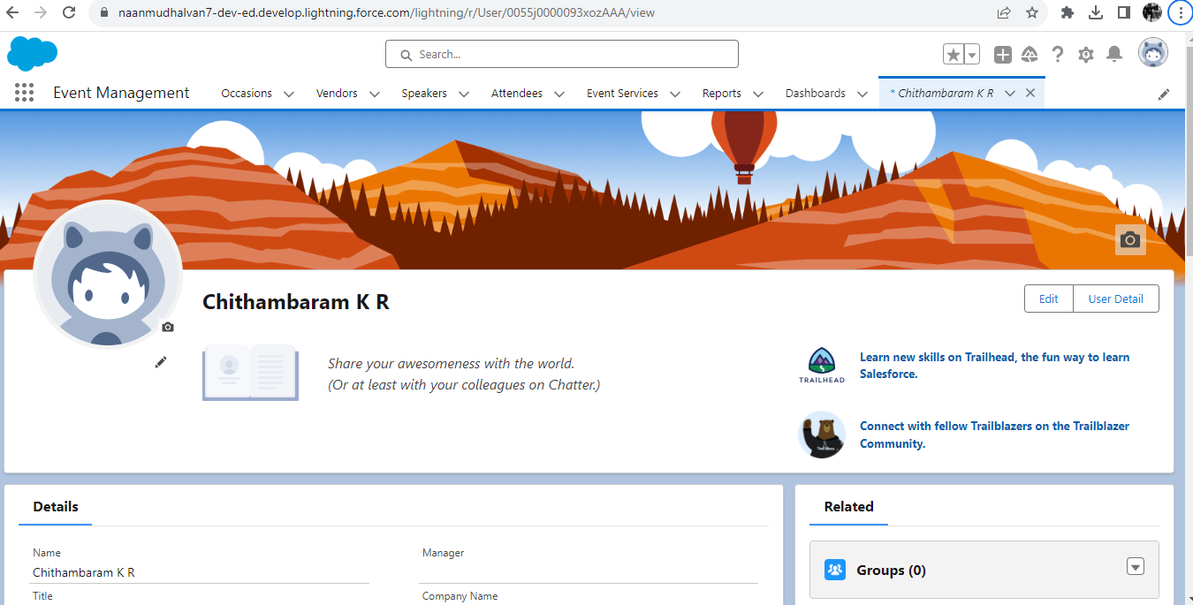

**Step 2: Create the objects (Attendee,Speaker,Vendor,Event Service,Occasion)**

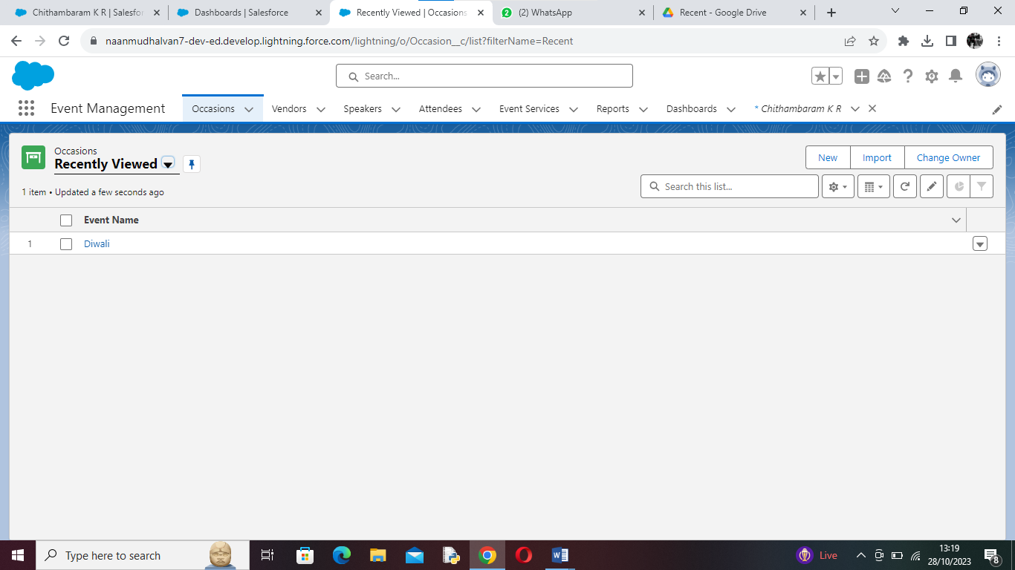

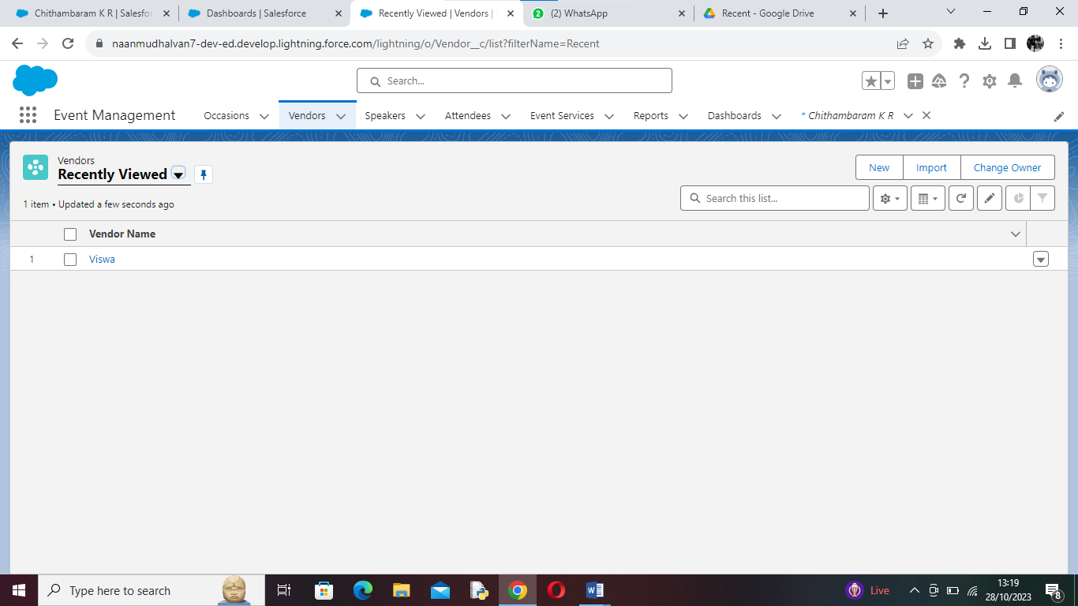

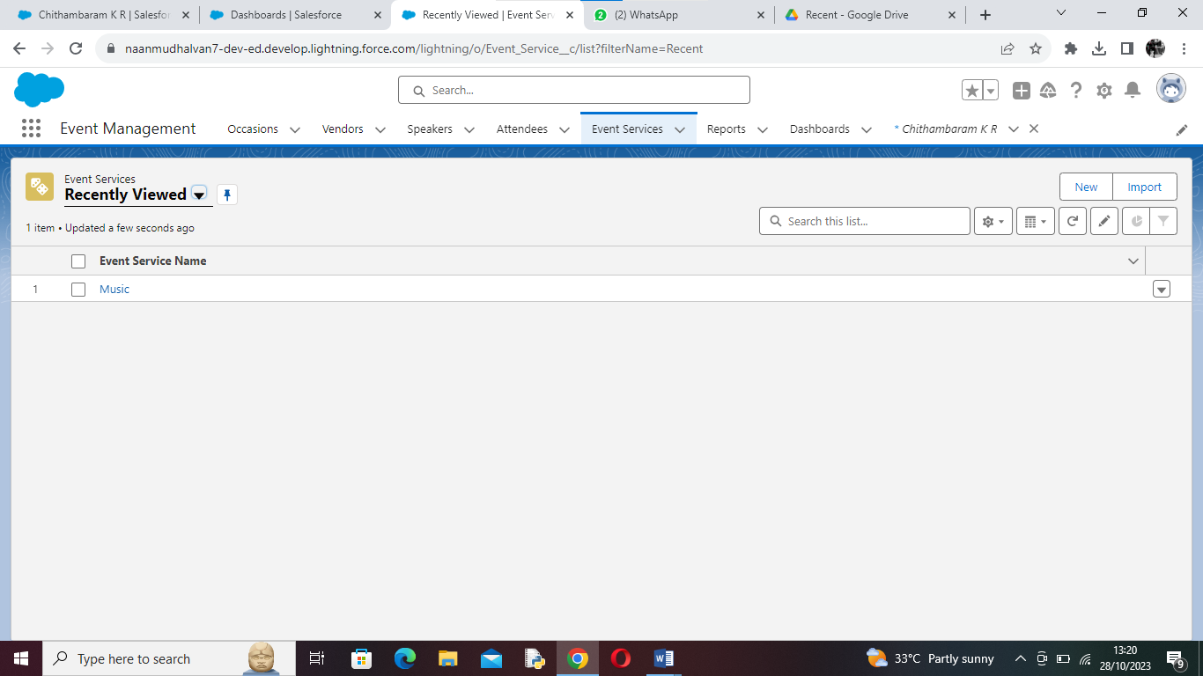

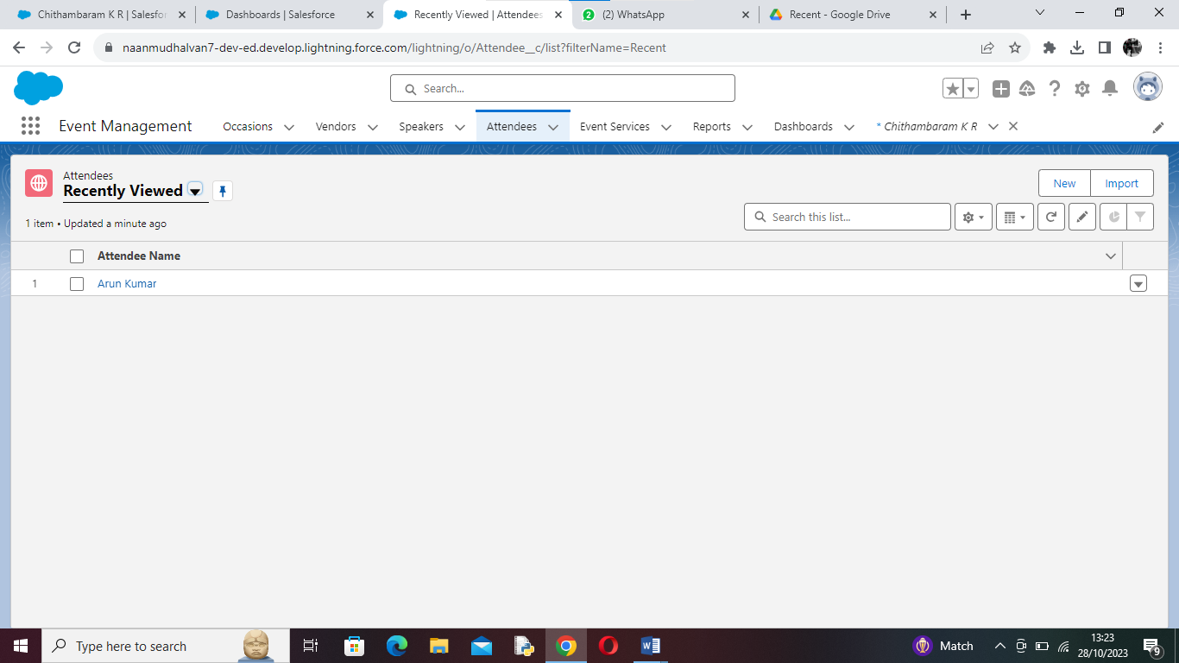

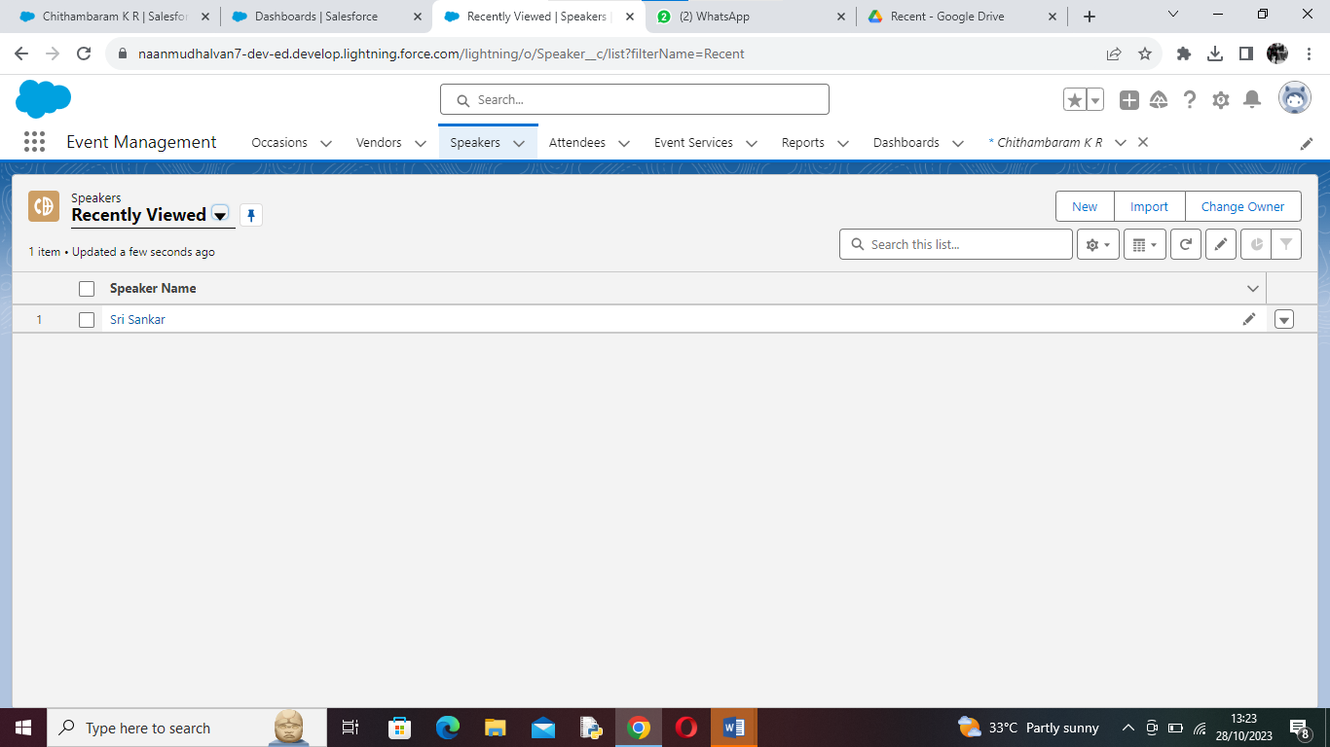

**Step 3: Create the Tabs for each objects (Attendee,Speaker,Vendor,Event Service,Occasion)**

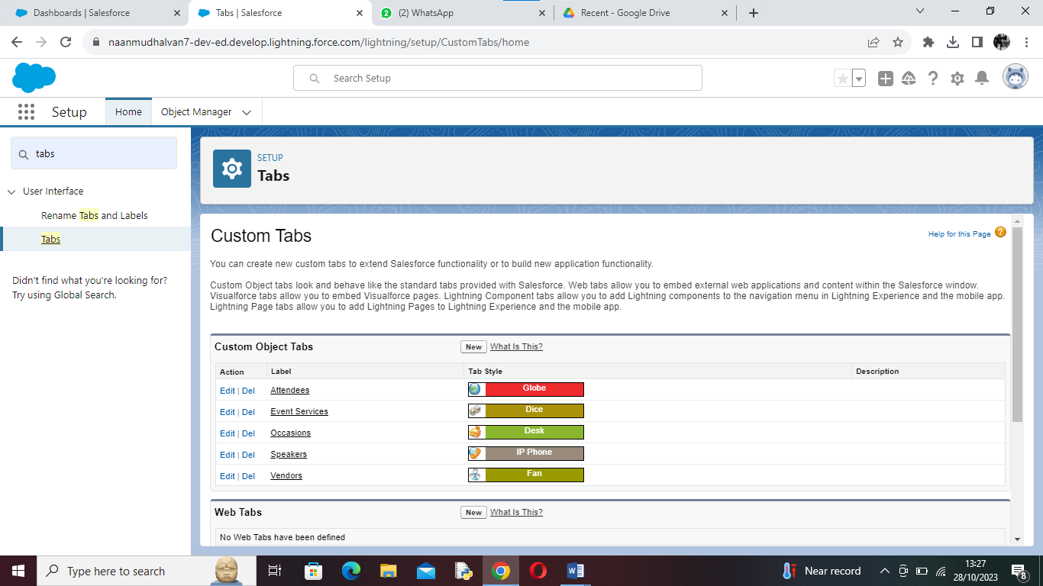

**Step 4: Create a Lightining App**

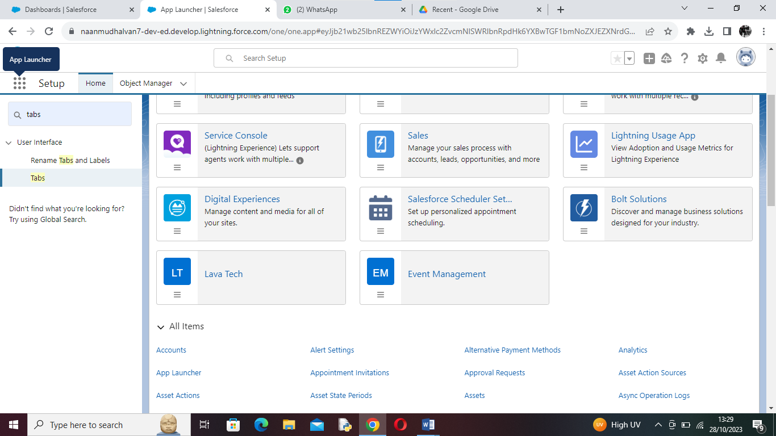

**Step 5: Create the Fields & Relationship for each objects**

